Sri Lanka Anti-Doping Agency

Annual Report 2024
English

Content

1. Organizational Information
2. Our Vision, Mission and Objectives

Summary of Major Performance

- Message from the Chairman

- Message from the Director General

6. Board of Directors - 2024
7. Board of Directors Report

8. Organization Structure and Cadre Information

9. Operational Progress
- Education and Testing Division
- Legal Affairs Division
- Enforcement and Implementation Division
- Research Division

10. Sustainability Report

11. Organizational Governance

12. Risk Management Report

13. Audit and Management Committee Report

14. Financial Report

15. Report of Independent Auditors

16. Audit report 2024 and actions taken by the management

SRI LANKA ANTI-DOPING AGENCY
Currently, the national and international sports sector has rapidly become commercialized. Due to high competition currently, they have been tempted to use illegal methods and achieve more victories.
As a result, substances and methods which are banned in sports have entered the field. Using these banned substances in national as well as international level sports will not only damage the authenticity of the sport but will eventually bring disrepute among the international community, as a country and also deteriorate the future generation in terms of health.
By following the World Anti-Doping Agency which was established in Montreal, Canada in 1999, to prevent the use of banned substances at the international level, prevention and demonstrations related to the use of banned substances within the Sri Lankan sports arena was handled by the Institute of Sports Medicine, until 2013.
On 18th of November 2013, the Convention Against Doping in Sports Act No.33 of 2013 was incorporated, as the requirement of a separate entity to function independently in order to address this subject which was already immerging, a Statutory Board named Sri Lanka Anti-Doping Agency was established under section three (3) of this act with the objective of eradicating prohibited substances and methods from Sri Lankan sports.
Currently Sri Lanka Anti-Doping Agency is functioning as a Statutory Board under the Ministry of Sports and Youth Affairs
The main objective of Sri Lanka Anti-Doping Agency is to eradicate substances which are prohibited to be used by the athletes in sports and promote clean sport.

Organizational Information
- Name of the Organization
Sri Lanka Anti-Doping Agency

- Legal Format
This organization was established under section three of the Convention against Doping in Sports Act No 33 of 2013

- Starting Date
10th of November 2013

- Registered address of the Office
No 363/12, Sugathadasa Stadium- Block D, Stadium Parking Road, Sirimavo Bandaranaike Mawatha, Colombo 14.

- Contact No
0113 071 838
0112 328 366

- E-mail id
sladasl@yahoo.com

- Website
www.antidopingsrilanka.org

- Tax Identification No.
409386822

- Auditor
Auditor General

- Bankers
Bank of Ceylon

Vision
Dope free Sri Lankan Sports Energy for right and fair Achievement

Mission
Implementation of the Convention against Doping in Sport Act. No.33 of 2013, in Compliance with the World Anti-Doping Code and it regulations

Objectives
Primary Objective

To support and drive compliance with the National Anti-Doping Policy in Sri Lanka.
Secondary Objectives

- Giving awareness to the Government, Sports Ministry and National Olympic Committee regarding the National Anti-Doping Policy.
- Being instrumental in implementing the 2021 World Anti-Doping Code and International Standards across Sri Lanka.
- Supporting all Sports Associations/Institutions to comply with the National Anti-Doping Police.
- Sharing up to date anti-doping practices and expertise knowledge with other anti-doping organizations, including WADA’s Regional Anti-Doping Organizations where relevant on a commercial basis.
- Cooperate with influential anti-doping organization including WADA and NADOs.
- Providing expert anti-doping advice and direction to high profile sporting events of national importance.
- Fulfilling all major event responsibilities according to the world class standard.
- Providing a risk based integrated program to prevent doping.
- Evaluating the risk of doping in sport in Sri Lanka utilizing internal and external experts.
- Increase the intelligence collection competencies from available bases, including law enforcement.
- Enable value-base strategies on prevention through education programmes across Sri Lanka’s sporting and educational landscape, supported by the growth of best practice tools and support services.
- Operate an intelligence-led, energetic and receptive testing programme.
- To promote a level playing field for athletes by applying international policy and practices.

Summary of Major Performance
Description | Number | 2019 | 2020 | 2021 | 2022 | 2023 | 2024
Conducting Dope Control Tests | Number | 260 | 106 | 177 | 138 | 130 | 145
Positive Cases | Number | 06 | 02 | 04 | 05 | 04 | 04
Conducting Disciplinary Inquiries | Number | 06 | 08 | 02 | 09 | 04
Conducting Appeal Inquiries | Number | 03 | - | 04 | 07 | 01
Providing awareness for athletes and related parties | Programs | 46 | 28 | 35 | 48 | 45 | 18
Number of participants for awareness programs | No of participants | 3357 | 965 | 1600 | 2316 | 2435 | 2265
Research abstract publication | Number | 00 | 01 | 00 | 02 | - | -
Research paper publication | Number | 00 | 00 | 02 | 01 | - | 05
Software development (Mobile and web) | No of participants | 01 | 01 | 00 | 00 | - | -
Total number of staff members | Rs.M | 23/27 | 22/28 | 23/29 | 19/29 | 17/29 | 18/29
Personal Emoluments | Rs.M | 13.4 | 13.4 | 15.5 | 16.7 | 15.9 | 18.6
Income | Rs.M | 0.72 | 2.93 | 1.85 | 2.32 | 5.13 | 4.92
Property, plant and equipment | Rs.M | 273 | 286 | 270 | 260 | 228 | 199
Current assets | Rs.M | 4.9 | 4.6 | 7.4 | 5.3 | 4.9 | 20.3
Current liabilities | Rs.M | 8.2 | 15.3 | 16.0 | 12.63 | 5.7 | 10.7

Message from the Chairman



I am pleased to announce that the Sri Lanka Anti-Doping Agency has demonstrated excellent performance during the financial year 2024. It is a fact that we all know that our institution is performing an unprecedented task in the Sri Lankan sports sector by obstructing the path of competitive sports devoid of fairness and discipline and maintaining the spirit of the game and guiding athletes towards a clean and genuine sports, over the years.

To elevate Sri Lanka's name to the international stage, anti-doping standards must be maintained continuously to ensure that Sri Lankan athletes who strive to participate in international sports competitions are not ineligible (Non-Compliance), our organization operates responsibly to maintain proper procedures that comply with international standards and regulations.

Whether a player wins or loses in a game, the self-esteem of a player remains unshaken in its purity and authenticity. Currently, doping has been identified as a major factor in determining the outcome of a sport. It has become a black mark, especially on the vitality and fairness of the game. However, we must remember that the only way to succeed in a sport is through constant practice, dedication, and unique talent. Doping can be described as an illicit by product of modern technological advancements.

In this context, the role of the anti-doping agencies operating under the World Anti-Doping Agency, which are scattered around the world, is very important. Dope control test data reports from the past few years confirm that the threat of doping is rising in Sri Lanka as well.

Based on the results of research, it was found that the awareness of Sri Lankan athletes regarding doping was insufficient, and after considering the public requests received in this regard, awareness programs in this regard were successfully organized island-wide over the past few years. This will provide an understanding of the consequences of doping, the legal consequences, and the impact on the future of the sport. In this regard, it is planned to implement awareness programs in the future, not only for those involved in sports, but also for other parties involved in this matter.

Even under the current challenging social and economic environment, it can be considered a great achievement for our institution to be able to continuously maintain all the programs, research and investigation activities implemented solely for the advancement of sports. We have been able to implement the law without any gaps, especially in the midst of the challenges, in bringing to justice those who pose a threat to the integrity and purity of the game. Accordingly, urine samples were tested for banned substances more frequently both in and out of competitions. Particularly, in 2024, a large number of athletes who have used banned substances were identified and appropriate action was taken against them.
Furthermore, doping control tests are conducted at national level sports competitions apart from them, at school level and other sports competitions.

Also, during this year, it was possible to obtain the support of UNESCO, and through that, various programs were organized, and an island-wide art competition was organized at the school level. The main objective was to improve anti-doping awareness among the student community. Outreach programs were also implemented vigorously. A special event this year was that an officer from our organization got the opportunity to represent the country at the Paris Olympics as an International Doping Controller Officer.

Doping tests continues to be conducted and chaperone training programs are being implemented more frequently. Furthermore, university students were involved in these training programs, and through this, the support of new officers with training and qualifications was also obtained during this year. Similarly, the research laboratory continues to conduct research and is also working on research articles. This also provides space for international level research.
Furthermore, financial responsibilities for the future well-being of the institution continued to be successfully met during this year. Accordingly, to make the activities of the institution effective, the Accounts Division is responsible for preparing financial reports. financial control and transaction activities of the institution and the Research Division is responsible for carrying out research and findings, Sports and community service programs are jointly carried out by the Education Division, while legal activities and related matters are jointly carried out by the Legal Division, and all activities are regulated, directed, and monitored by the senior management of the institution.

I would like to express my gratitude to all the parties who have worked with effort and, dedication and supported the institution in various ways throughout the past year, demonstrating such excellent performance. In the same way, I wish that in the coming years, everyone will have the necessary strength and courage to give life to the vision and mission of the institution, paving the way for the further development of clean and genuine sports in a systematic and meaningful manner.

Professor Arjuna De Silva
Chairman
Sri Lanka Anti-Doping Agency

Message from the Director General



The Sri Lanka Anti-Doping Agency was established in accordance with the Convention Against Doping in Sport Act No. 33 of 2013 with the objective of eradicating prohibited substances and prohibited methods used in sports and building a clean sporting environment in Sri Lanka.

In line with that noble objective, and in order to educate school students, necessary arrangements were made to include these matters in the school textbooks for grades 6-11. The revised syllabus is scheduled to be included in the school textbooks by 2026.
The primary function of our institution is to conduct awareness programs to prevent the use of prohibited substances. Accordingly, 18 programs were conducted in 2024 for 2265 athletes, coaches and support personnel who work with athletes. Dope Control tests were also conducted throughout the year, with 79 in-competition and 66 out-of-competition tests were conducted.

Although 11 years have passed since the establishment of the institution, the Convention against Doping in Sports Act No. 33 of 2013 has not been amended.
Therefore It is an achievement that we have identified the obstacles to create a clean sports environment and completing the preliminary work required to include the amendments which needed to overcome them in the draft .
Moreover, Sri Lanka has been able to obtain a major portion of the funds from the Fund to Eliminate Doping in Sport under the United Nations Convention on Anti-Doping, which will help athletes, pharmacists, support staff, and police officers and spread the knowledge throughout Sri Lanka.

Therefore, it is with heartfelt joy that I look back on the year 2024. I hope that the Sri Lanka Anti-Doping Agency will be able to create a clean sports environment in Sri Lanka in the future as well.


Dr. Shiromi Pilapitiya De Alwis
Director General
Sri Lanka Anti-Doping Agency

Board of Directors - 2024
Professor. Arjuna De Silva Chairman   |  |  | Mr.Panduka Keerthinanda  Member |  | Professor. Ravindra Fernando  Member  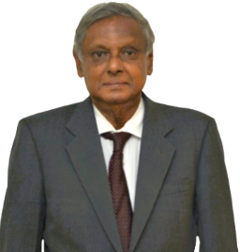
Professor.Shemal Fernando  Member  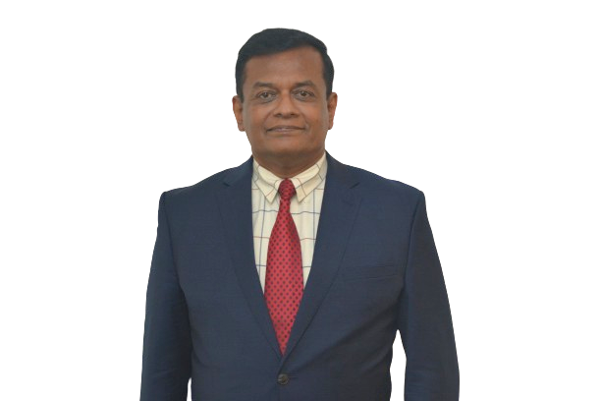 |  |  | Ms.M.N.N.Sufna  Member |  | Dr. Lal Ekanayake  Member  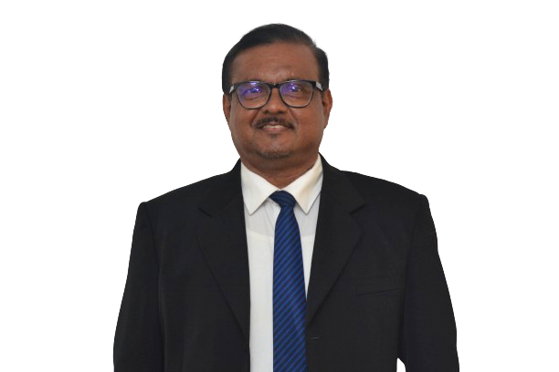
Mr. Sajith Jayalal  Member   |  |  | Mr.H.M.M.S.DharmawardhanaMember  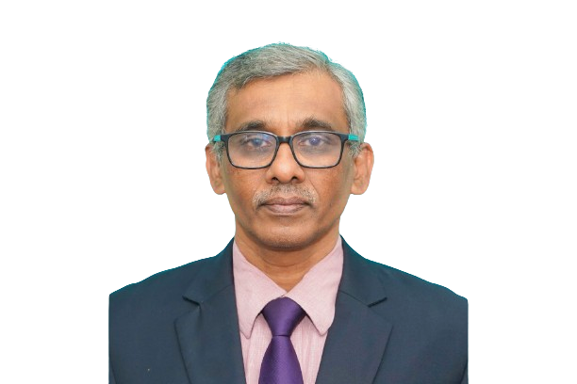 |  | Dr. Anver Hamdani  Member  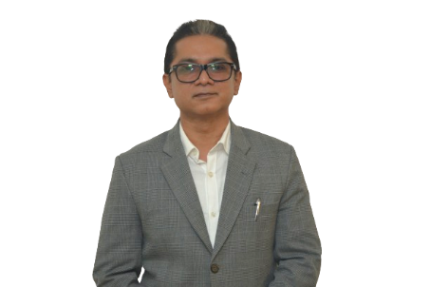
 | 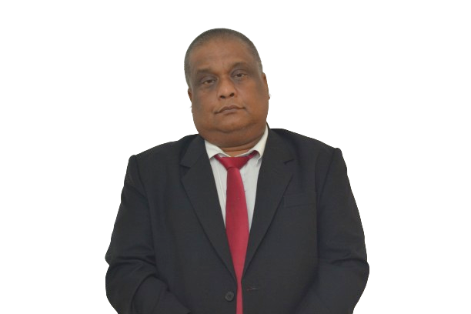  Dr. Rukshan Bellana  Member |  | W.S.K.Liyanagama  Member
Directors Report
Responsibilities of the Board of Directors
According to the Convention against Doping in Sports Act No.33 of 2013 section no.15, it shall be the duty of the Board to advice the Minister on any or all of the matters related to the objects of the Agency and for any such matter referred to the Board for advice by the Minister.
Furthermore, according to section no.16 of the Act, the Minister may from time-to-time issue special or general directions in writing relating to the exercise of the power and the performance of the duties with relevant to the Board, and the Board shall give effect to such directions.

Administrative Role
According to the Convention against Doping in sports Act No.33 of 2013, the administration, management and control of the affairs of the agency shall be vested in to the Board of Directors. It is the responsibility of the Board of Directors to exercise, perform and discharge the powers, duties and functions conferred or imposed on or assigned to the Agency by the Act, for the purpose of administering the affairs of the Agency.

Leadership Role
In its leadership role, the duties of the Board should include, governance and direction to the functioning of following.

- Planning, co-ordinating, implementing and monitoring anti-doping activities.
- Taking measures against anti-doping rule violations.
- Acquiring (whether by sale, gift or otherwise) holding, taking or giving on lease or hire, mortgage pledge and sell or otherwise dispose of any movable or immovable property.
- Open and maintain current and saving accounts in any bank.
- Accepting grants or donations from persons or bodies of persons, whether in or outside Sri Lanka.
- Enter into or perform, all such contracts as may be necessary for the exercise of its power or the discharge of its functions.
- Investing money belonging to the Agency.
- Borrowing such sums of money as may be necessary for the purpose of discharging its function.
- To appoint, employ, remunerate and exercise disciplinary control over and dismiss such officers and servants as are necessary for the discharge of the function of the Agency under this Act.
- Charge fees for the services and assistance provided by the Agency.
- Doing all other things which in the opinion of the Agency are necessary to facilitate the discharge of its functions.

Composition
The board comprises of ten (10) members, inclusive of the Chairman of Sri Lanka Anti – Doping Agency.

- Professor. Arjuna De Silva - Chairman
- Mr.Panduka Keerthinanda - Member
- Professor. Ravindra Fernando - Member
- Professor.Shemal Fernando - Member
- Ms. M.N.N.Sufna - Member
- Dr. Lal Ekanayake - Member
- Mr. Sajith Jayalal - Member
- Mr.H.M.M.S.Dharmawardhana - Member
- Dr. Anver Hamdani - Member
- Dr. Rukshan Bellana - Member
- Mr. W.S.K.Liyanagama - Member

Meetings & Attendance
The Board met in 09 occasions during the Year 2024 and attendance of the Board of Directors was as follows.
Name | 18th January | 02nd February | 21st March | 25th April | 28th May | 27th June | 25th July | 22nd August | 19th September
Professor. Arjuna De Silva
Mr. Sajith Jayalal |  |  |  | - | -
Dr. Lal Ekanayake
Dr. Anver Hamdani |  |  |  | - | - | - | - | - | -
Professor. Ravindra Fernando | - |  |  |  |  |  | - | -
Mr.H.M.M.S.Dharmawardhana
Dr. Rukshan Bellana |  | - |  | - |  | - |  | - | -
Professor.Shemal Fernando | - | - | - |  |  | - | - | -
Mr.Panduka Keerthinanda
Ms.M.N.N.Sufna |  |  |  |  |  |  | - |  | -
Mr.W.S.K.Liyanagama (Mr.W.S.K.Liyanagama participated as the Treasury representative instead of Mr.H.M.M.S.Dharmawardhana since February )

Organizational Structure

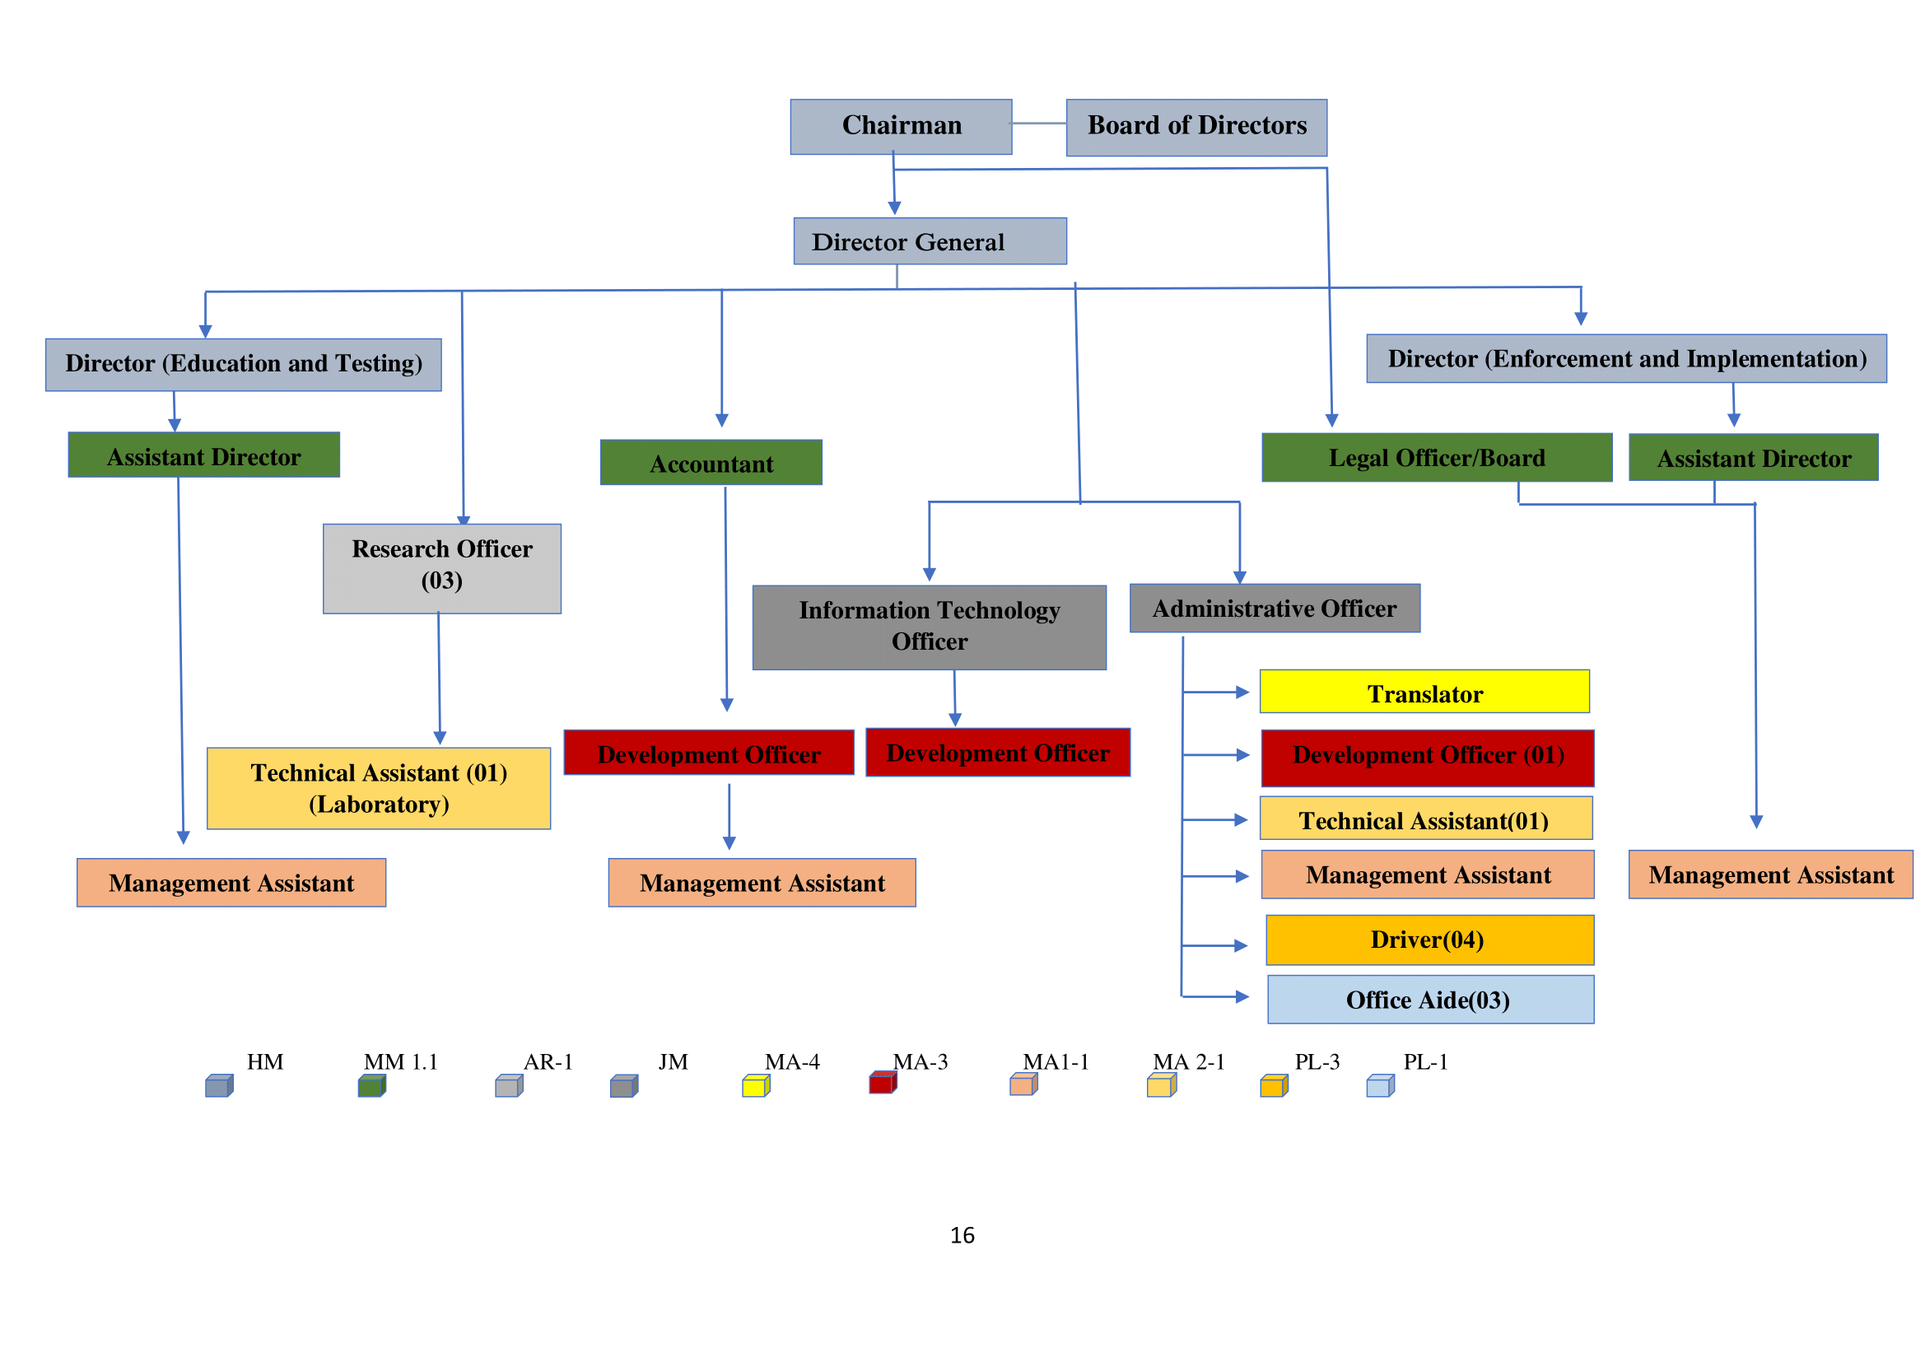

Cadre Information
The cadre approved by the Department of Management Services is 29 for Sri Lanka Anti-Doping Agency.
 | Designation | Salary Scale | Number of Posts | Current number of employees | Number of vacancies
1. | Director General | HM 2 - 1 | 1 | 1 | -
2. | Director | HM 1-1 | 2 | 1  (Tempory) | 1
3. | Assistant Director/Deputy Director | MM 1-1 | 2 | 2 | -
4. | Accountant | MM 1-1 | 1 | 1 | -
5. | Legal Officer/ Board Secretary | MM 1-1 | 1 | 1 | -
6. | Research Officer | AR 1 | 3 | 2 | 1
7. | Administrative Officer | JM 1-1 | 1 | - | 1
8. | IT Officer | JM 1-1 | 1 | - | 1
9. | Translator | MA - 4 | 1 | 1 | -
10. | Development Officer | MA - 3 | 3 | - | 3
11. | Management Assistant | MA 1-1 | 4 | 2 | 2
12. | Technical Assistant | MA 2-1 | 2 | 2 | -
13. | Driver  *Due to vacancy in the driver position, one driver is appointed through the Ministry of Youth Affairs and Sports on temporary basis | PL 3 | 4 | 2 | 2
14. | Office Aide | PL 1 | 3 | 3 | -
Total |  |  | 29 | 18 | 11

Operational Progress
Education Division
SLADA Education Initiatives 2024
SLADA initiate following 3 key projects in year 2024 with collaboration Ministry of Education and Higher education.

- In collaboration with SLADA National Institute of Education (NIE) has introduced a new Health and Physical Education curriculum for grades 6 to 11, starting in 2024. It includes a module on "Rules and Ethics in Sports," with 3 hours of annual learning on Clean Sport.
- SLADA, in partnership with NIE, is launching a nationwide training programme to equip PE teachers with the knowledge to teach the new Anti-Doping module. A 30-hour programme will be implemented in 10 National Colleges of Education in Sri Lanka.
- SLADA is also working to integrate Anti-Doping education into the Sports Law module within Sri Lankan government university sports Science Degree Programmes.

SLADA Clean Sport Educators
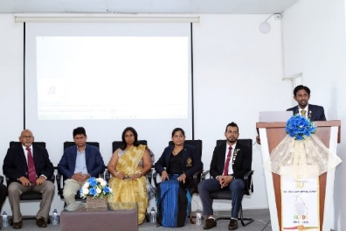
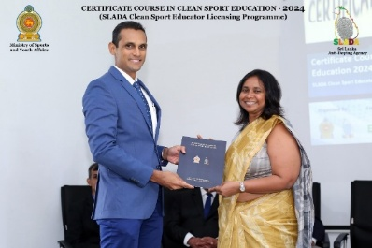
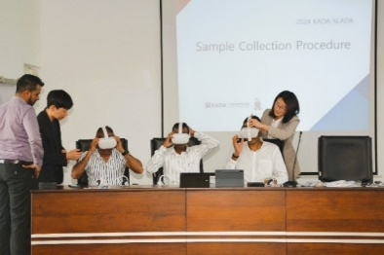

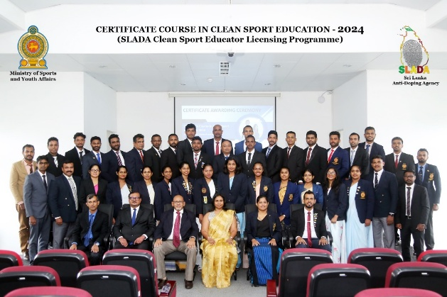
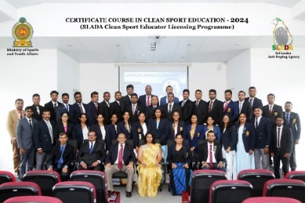
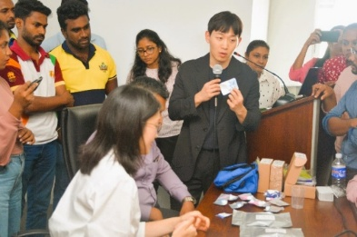

In 2024, SLADA launched a 3 month Certificate Course in Clean Sport Education to train 40 part-time Clean Sport Educators. This initiative ensures that every district now has at least one educator, enabling SLADA to conduct island-wide Clean Sport Education Programmes with minimal travel and reduced costs.
Clean Sport Education Programmes
In 2024, SLADA conducted 70 Clean Sport Education Programmes across the island. The summary of these programmes is as follows.

Anti-Doping Testing 2024

Most Number of Testing
Athletics | 20%
Cricket | 19%
Para-Athletics | 9%
Weightlifting | 8%

Legal Division
Progress of year 2024

- Conducting disciplinary inquiries against athletes reported positive in late 2023 and 2024 and announcing their final decisions
- Conducting appeal inquiries to provide clear final decisions in appeal inquiries.In each such case, preparing verbal and written submissions and making arrangements to obtain the necessary legal support.
- Proper communication of decisions relevant to appeal and disciplinary inquiries to the relevant parties.
- Conducting appeal inquiries and disciplinary inquiries appropriately through online technology.
- Taking the necessary initial steps to submit the 2025 Prohibited list for parliamentary approval.
- Taking the necessary initial steps to submit the Equine Prohibited list for parliamentary approval.
- Raising awareness about the legal background of banned substances during awareness programs.
- Conducting board meetings in a new phase , away from the traditional method using online technology.
- Initiating the necessary steps to amend the Convention Against Doping in Sport Act No.33 of 2013 in accordance with the regulations of the World Anti-Doping Agency and the existing requirements of the Agency.

Enforcement and Implementation division
Progress in year 2024
Program | No of programs | No of participants
Training programs | 9 | 957
Outreach programs | 9 | 1308

Complaints and Investigation reports | Programs | No of participants
Complaints received | 6 | 6
Internal preliminary investigation reports | 3 | 3

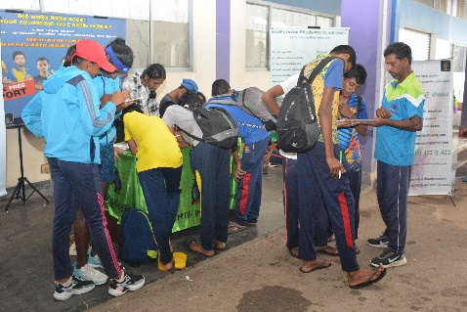
Outreach program held at the Diyagama, Mahinda Rajapakse ground on 2024.07.15 and 16.

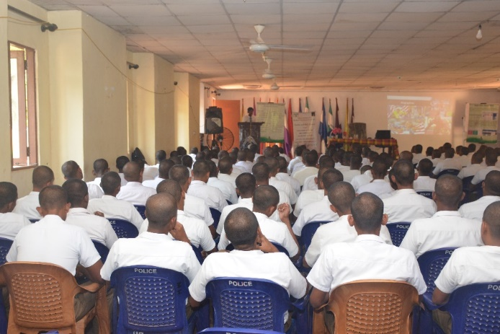

Training program for Police officers held on 2024.08.01 at the Pahalagama Police Training College

Research Unit
- 5 research projects initiated in collaboration with the Department of Chemistry, University of Sri Jayewardenepura were successfully completed and the abstracts of those research projects were submitted at scientific conferences and published.

- A Memorandum of Understanding was signed with the Department of Chemistry of the University of Sri Jayewardenepura to conduct collaborative research activities in order to expand the research activities of the SLADA Research Division.

- A laboratory research project was initiated and successfully completed in collaboration with the Chemistry Department of the University of Kelaniya.

- A new social science research project was initiated in consultation with the Food and Nutrition Department of Wayamba University. The data collection has been completed and the data analysis is in progress.

- Preliminary discussions were held to sign a Memorandum of Understanding with the Chemistry Department of the University of Kelaniya.

- A workshop was created using the LC-MS/MS instrument to generate income using the SLADA laboratory and the workshop was held for university students, lecturers and researchers for a fee.

- Furthermore, advertisements were created and advertised through electronic and social media to inform external parties about the testing services and research facilities that can be provided by the SLADA Laboratory to generate revenue using the LC-MS/MS instrument and the SLADA Laboratory. In addition, universities and institutions were also informed through letters.

- Revenue was generated by testing samples from external parties using LC-MS/MS equipment.

- Discussions were held with private university lecturers on ways to provide opportunities for students to conduct research using the LC-MS/MS instrument and the SLADA laboratory. As agreed, a research team from the private university ICHEM was given the opportunity to conduct part of their research using the SLADA laboratory, and a cost estimate was made and funds were obtained for this.

- SLADA initiated Collaborative Research in consultation with external institutions to minimize the cost of laboratory research, and they agreed to provide some of the expensive chemical reagents required to conduct the research.

- Further training was received from the Local Agent on the analytical methods that can be performed using the LC-MS/MS instrument and its advanced applications.

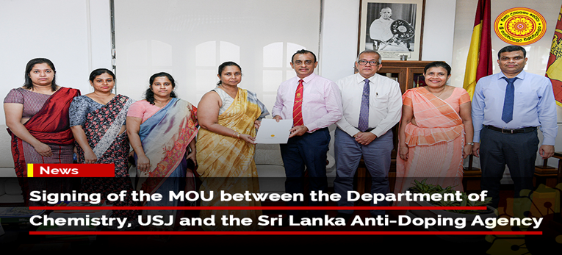
Signing of a Memorandum of Understanding with the Department of Chemistry, University of Sri Jayewardenepura.

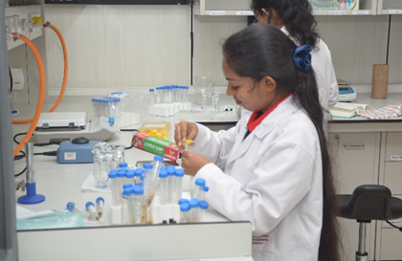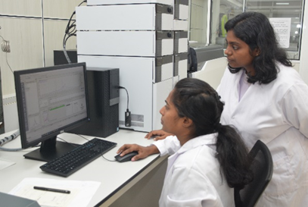
University students conducted research using LC-MS/MS equipment.

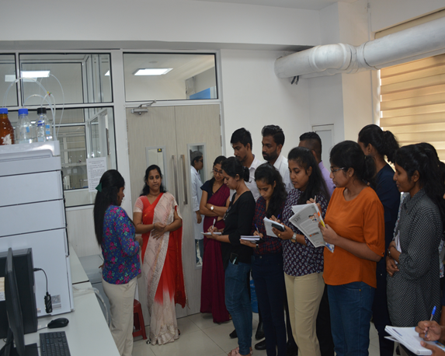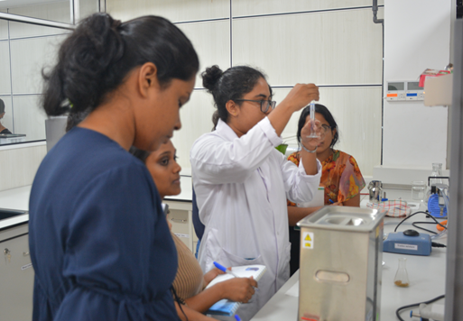

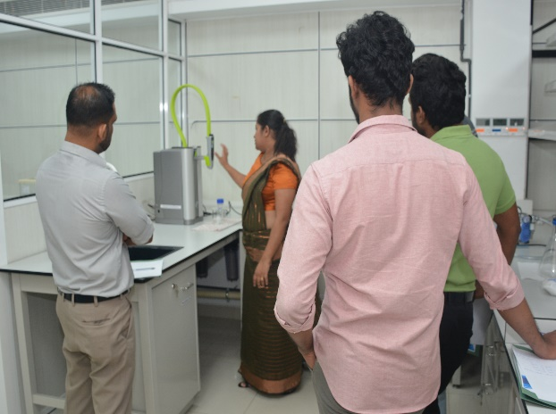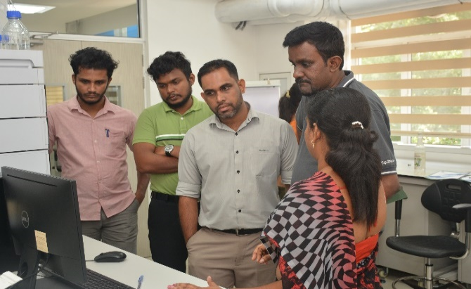
Workshops conducted using LC-MS/MS equipment.
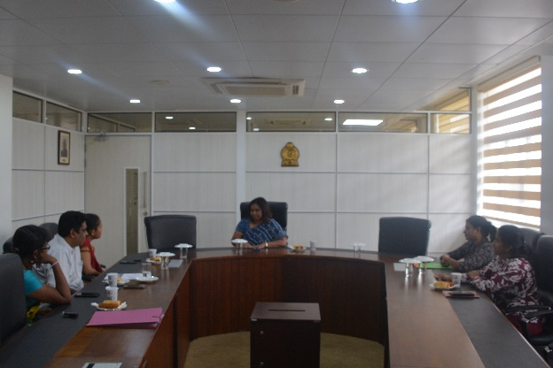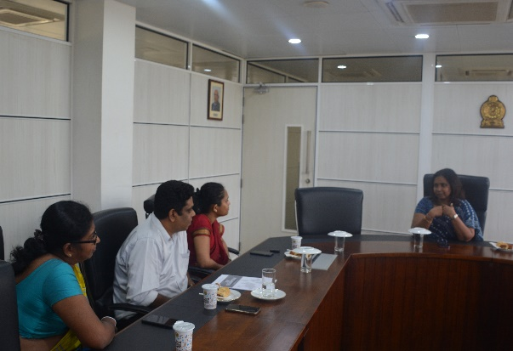
Preliminary discussions were held to sign a Memorandum of Understanding with the Chemistry Department of the University of Kelaniya.

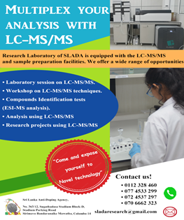
Creating and distributing advertisements via electronic and social media to educate external parties using the LC-MS/MS instrument and SLADA laboratories.

A research team from ICHEM Private University is having a discussion on using the SLADA lab to conduct part of their research.
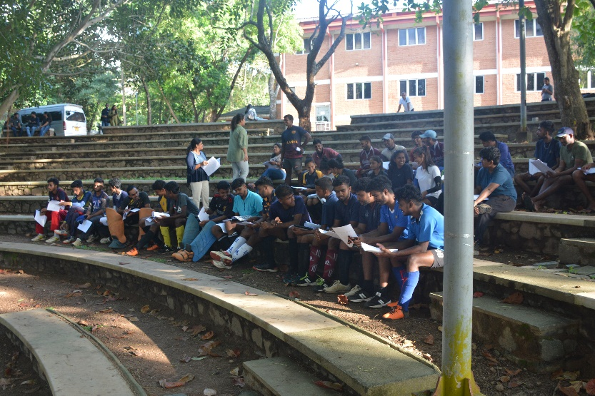
Data collection for social science research.
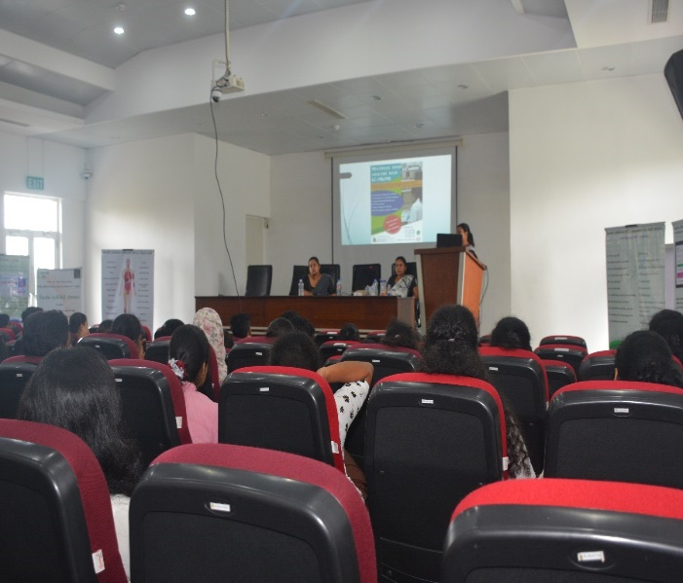
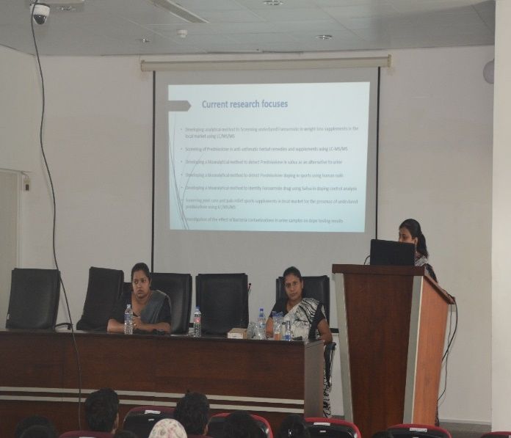
Educating university students about research conducted using the SLADA laboratory and services available through the SLADA Research Division.

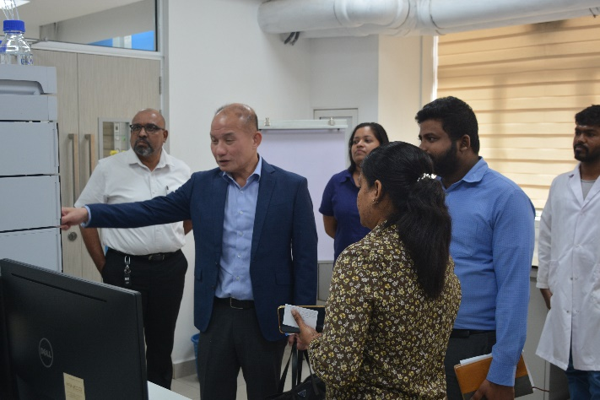
Discussions with the heads of Shimadzu and Hayleys to obtain further training on the usage of LC/MS/MS equipment.

Sustainability Report
"The Sri Lanka Anti-Doping Agency is committed towards responsible growth, which creates a constant and sustainable value for Sri Lankan Athletes through its corporate objectives."



Sustainability Report

Sri Lanka Anti-Doping Agency has been an institution that primarily maintains sustainability. Since its inception, the Sri Lanka Anti-Doping Agency has taken more than just the welfare of its immediate stakeholders into account and firmly believes that it does not conflict with the overall long-term interests and values ​​of the players. The Board's sustainability report consists of its profile, strategy for sustainability, economic responsibility, social responsibility and environmental responsibility
The Sri Lanka Anti-Doping Agency is committed to responsible growth that creates consistent and sustainable value for players through the achievement of its objectives. This report highlights the steps taken by the Sri Lanka Anti-Doping Agency to maintain social, environmental and economic responsibility. The social responsibility of the Sri Lanka Anti-Doping Agency includes the responsible actions taken for the safety of the Agency, the athletes, and the Sri Lankan citizens. To achieve environmental responsibility, the Sri Lanka Anti-Doping Agency monitors the environmental impact of its corporate activities and makes environmentally friendly investments. Economic responsibility transforms into a transparent and balanced governance model.
Our core values

When it comes to our dedicated and highly enthusiastic employees, they have given us immense support. That's why we work hard to create an environment where they can be proud to be a part of it. We invest in our employees by providing opportunities for training and continuous education to encourage excellence in our workforce because we understand that the success of our organization depends on their job satisfaction.
Environmental responsibility
Our efforts which have been undertaken to minimize the impact on the environment have been successful. The Sri Lanka Anti-Doping Agency opens a gateway to provide effective support services through effective staff training, modern technology and collaboration with stakeholders. The introduction of the App is a testament to these goals. Through digitization, Sri Lanka Anti-Doping Agency aims to reduce its carbon footprint on the planet by introducing more applications and e-services for the convenience of its players. We also intend to improve Sri Lanka Anti-Doping Agency’s operations on environmental impact and increase awareness on the green concept among the employees. Sri Lanka Anti-Doping Agency focuses

on creating sustainable value through dedicated development. The Sri Lanka Anti-Doping Agency monitors the environmental impact of its activities and invests in energy conservation to fulfill its environmental responsibility.
Our social responsibility
As Sri Lanka Anti-Doping Agency we require to recognize us as a valued community member based on our Corporate Social Responsibility policies. Therefore, the Sri Lanka Anti-Doping Agency focuses on providing contributions to athletes and the community through meaningful, long-term partnerships and conducting corporate activities in an environmentally sustainable manner.
Human Resources
We recognize the important role our employees play in developing good business practices and building up long-lasting customer relationships. We deeply value our employees and have created and delivered an innovative, collaborative and engaging workplace to demonstrate our appreciation for the invaluable contributions they make.
Objectives of staff development

- Creation and promotion of employment and career opportunities

- Continuously improving workforce planning and skill management programs, quality recruitment and retention measures, developing leadership and succession planning, and provide continuous knowledge
- Ensuring that our employees are empowered and incentivized for their achievements.

- Ensuring that our staff are well informed and aware of the corporate strategic direction.

Corporate Governance

The Corporate Governance System defines the principles of guiding the Sri Lanka Anti-Doping Agency's decision-making practices, while also guiding the Board's long-term objectives and strategic plans. The Corporate Governance Model summarizes the division of powers and responsibility between the different levels of the Sri Lanka Anti-Doping Agency, particularly between the levels of governance, that is the division of powers and responsibilities between the Board of Directors and Executive Management levels is succinctly highlighted. The Board of Directors establishes the corporate policies and provides strategic guidance to the Chief Executive Officer and Executive Officers, who are responsible for the smooth functioning of the institution.

The Sri Lanka Anti-Doping Agency is governed by the Convention Against Doping in Sports Act, No. 33 of 2013. The structure of the Board as defined under section 14(i) of the act, as follows.

(a) Ex-officio members, namely:
- An officer not below the rank of Senior Assistant Secretary nominated by the Secretary to the Ministry of the Minister to whom the subject of Sports is assigned;
- The Director-General of Sports Development;
- The Director-General of the National Institute of Sports Medicine;
- The Director of the National Institute of Sports Science;

(b) Six members appointed by the Minister (hereinafter referred to as the “appointed members”) distinguished in the field of law, sports medicine, and sports science.

The Minister shall appoint the Chairman of the Board and as the Chief Executive Officer of the Board, the Chairman shall be responsible for the administration and management of the Board's affairs.

Role of Board of Directors
The Board of Directors is responsible for the efficient management of the institution by the government policies. This must be achieved by ensuring that resources are safeguarded, adequate accounts are maintained and accurate reports are compiled while complying with all statutory and management regulatory requirements.Hence, the following should be ensured by the Board of Directors:

- Ensuring that the strategic objectives of the organization are being implemented.
- Provide leadership to achieve the strategic objectives
- Ensuring that an effective internal control and risk management system is in place
- Effectively supervise the management activities of the organization
- Adequate reporting of financial aspects and disclosures required on a regular basis.
- Responsible use of resources and assets
- Appointment of Audit Committee and other committees; and introducing a code of conduct and ethics and a corporate governance strategy
- To be responsible for all their activities as per relevant ordinances, guidelines and circulars etc.
- Appraisal of the chief executive and senior management staff at least annually.

Meetings of the Board
Corporate operations and outcomes of board meetings are rigorously and regularly monitored in line with budgets and relevant standards. A standard agenda is followed along with other matters requiring detailed attention of the Board of Directors. The Board of Directors meets once a month and special Board meetings are held based on the requirement.

SLADA Committees
1. Therapeutic Use Exemption (T.U.E) Committee
2. Disciplinary Panel
3. Appeal Panel
4. Audit and Management Committee
5. Procurement Committee

Management

The day-to-day operations of the Sri Lanka Anti-Doping Agency are assigned to the Chief Executive Officer and the top management and senior management teams. The teams ensure that risks and opportunities are identified timely actions are taken and budgets are set to meet the targets.

Risk Management Report

Effective risk management is a key component of Sri Lanka Anti-Doping Agency’s process. We strive to maintain an appropriate equilibrium between the risks and outcomes of our business and continuously improve our risk management capabilities to help us execute our growth plans in a controlled environment. Risk management is a key component of the Sri Lanka Anti-Doping Agency's operational structure. We seek to limit adverse fluctuations in earnings and capital by managing risk exposures within the level of risk we are prepared to bear.

The management system includes a responsible approach to risk identification and mitigation.

Our main focus has been to create a strong risk management culture that supports risk awareness practices and thereby supports risk-based decision-making. We will continue to improve our risk strategies to ensure the long-term sustainability of the Sri Lanka Anti-Doping Agency.

The Sri Lanka Anti-Doping Agency's risk management strategy operates as a feedback mechanism for specific stakeholders, managers, and Boards of Directors. It is unique in its position as a strategic hub for informed decision-making for the organization's procedures, operations, systems and services.

This provides a consistent approach to strategic and business planning, project management, and business process levels to address business risks through the following:

- Provide a common understanding of risks across business functions and units.
- Provide continuous risk assessment to the management to facilitate improved prioritization and decision-making.
- Increasing employee awareness and management responsibilities The Sri Lanka Anti-Doping Agency is subject to a specific set of risks as outlined below.

Financial risk
Ineffective cash flow management and risks related to financial information can harm the productivity of organizations. Sri Lanka Anti-Doping Agency utilizes financial risk management practices such as coordinating cost control strategies across the organization.
Operational risk
Operational risks include potential losses due to system outages, human error, criminal activity or internal systemic breakdowns. Such situations can damage customer credibility and corporate image. The Sri Lanka Anti-Doping Agency continuously improves internal controls to minimize operational risks. To mitigate the threat posed by organizational risk, the management of the Sri Lanka Anti-Doping Agency conducts regular risk assessments of operational units and business processes.

Legitimacy Risk
Failure to protect against potential future legal action against the Sri Lanka Anti-Doping Agency increases the risk of legal damages. The Sri Lanka Anti-Doping Agency has consulted recognized legal professionals and taken appropriate steps to minimize such actions.

Information Technology Risk
Accurate and timely information obtained through the IT system is a fundamental part of the operational process of the Sri Lanka Anti-Doping Agency. Sri Lanka Anti-Doping Agency has launched an action plan to improve its IT system.

Audit and Management Committee Report

We are pleased to present our report for the financial year ended in 31st December 2024.

Composition of the Audit Committee

The Audit Committee consists of the following three (03) Non-Executive Directors.
- Mr.W.S.K.Liyanagama - Chairman
(Additional Director, Department of Public Enterprises)
- Ms.M.N.N.Sufna - Member
(Senior Assistant Secretary, State Ministry of S.I.D.D )
- Dr.Lal Ekanayake - Member
(Director General, N.I. Sports Medicine)
The Director General, Accountant, Administrative Officer, and other relevant officers must attend these meetings. The Audit Officer of the Auditor General's Department and Chief Internal Auditor of the State Ministry of Sports will participate in these meetings as observers of the committee.

Role of the Audit Committee
The Sri Lanka Anti-Doping Agency must maintain a strong internal control system to establish fair play and protect the assets of the institution. The committee also follows the guidelines issued by the Ministry of Finance and the relevant authorities. A summary of the activities carried out by the Audit Committee in relation to its main responsibilities during the year ended in 31st December 2024 is given below.

- Timely audit reports on internal audits conducted time to time in accordance with the approved annual audit plan are submitted by the internal auditor. These internal audit reports highlight the drawbacks in the existing systems and procedures of the institution, and after discussing the implementation of the recommendations, improvements in the existing methods and procedures will be recommended where necessary, and report the progress to the management and audit committee.

The audit committee receives proper reports from the internal audit, and the reports include a summary of the findings of each audit conducted during the period. The views of the management are also part of it and the committee reviews the basic facts that led to the conditions observed by the audit and the factors that led to those conditions and the actions to be taken to prevent the recurrence of those conditions.

- With the assistance of internal audit and government audit, the committee assesses the effectiveness of the institution's operational and financial controls and procedures, including expenditure, revenue process and capital expenditure authorization limits, signing authorities, control and development of information technology applications, organizational structure, policies, segregation of duties and management reviews. Liquidity status of the institutions financial statement position was constantly monitored. Deficiencies identified therein are reported along with recommendations for necessary improvements.

Number of Audit Meetings Conducted
Three (03) Audit Meetings have been conducted for the year 2024 and the attendance is as follows
Audit Committee | Presence | Absence
Mr.W.S.K.Liyanagama | 3/3 | No
Ms.M.N.N.Sufna | 3/3 | No
Dr.Lal Ekanayake | 3/3 | No
Mrs.B.L.D.Balasooriya | 3/3 | No
Mrs.D.H.Kalangsuriya | 2/3 | *1/3
*Mrs. H.N.S. Perera (in place of Mrs. D.H. Kalansuriya) | 1/3 | -

W.S.K.Liyanagama
Chairman
Audit and Management Committe





FINANCIAL REPORT

- STATEMENT OF FINANICAL POSITION
- STATEMENT OF FINANCIAL PERFORMANCE
- CASH FLOW STATEMENT
- STATEMENT OF CHANGES IN EQUITY
- NOTE TO THE FINANCIAL STATEMENT
- REPORT OF INDEPENDENT AUDITORS
- ACTIONS TAKEN BY THE MANAGEMENT

SRI LANKA ANTI DOPING AGENCY (SLADA)
STATEMENT OF FINANCIAL POSITION

 | Note | 31st December 2024 | 31st December 2023
 |  | (In Sri Lankan Rupees)
ASSETS
Non-Current Assets
Property, Plant and Equipment | 1 | 199,721,723.87 | 228,251,532.25
 |  | 199,721,723.87 | 228,251,532.25
Current Assets
Stock | 2 | 9,823,922.09 | 933,947.00
Trade & Other Receivables | 3 | 1,414,447.42 | 603,000.00
Prepayments | 4 | 93,477.24 | 1,677,665.12
Other Financial Assets | 5 | 5,755,362.26 | -
Cash & Cash Equivalents | 6 | 3,253,756.55 | 1,773,913.40
 |  | 20,340,965.56 | 4,988,525.52
Total Assets |  | 220,062,689.43 | 233,240,057.77
EQUITY AND LIABILITIES
Financed by:
Treasury Grant | 7 | 171,330,102.43 | 188,029,846.83
Other Grants | 8 | 3,302,464.38 | -
Accumulated fund | 9 | 13,668,777.25 | 13,801,400.64
Revaluation Reserve | 10 | 23,502,228.35 | 23,502,228.35
 |  | 211,803,572.41 | 225,333,475.82
Non-Current Liabilities
Provision for Gratuity | 11 | 2,170,377.02 | 2,161,920.00
Current Liabilities
Creditors & Retention | 12 | 2,746,469.83 | 2,106,217.80
Accrued Expenses | 13 | 3,302,270.17 | 3,598,444.15
Refundable Deposit |  | 40,000.00 | 40,000.00
 |  | 6,088,523.00 | 5,744,661.95
 |  | 220,062,689.43 | 233,240,057.77
Financial Statements have been prepared in accordance with the Sri Lanka Public Sector Accounting Standards (SLPSAS).
Accounting policies & notes to accounts on pages 05 to 12 form an integral part of these Financial Statements.
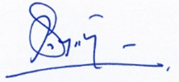


……………………………….. |  |  | ………………………............
D.K.J.Chathurika |  |  | Dr S.P.P. De Alwis
Accountant |  |  | Director General
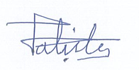
The Board of Governors are responsible for the preparation and presentation of these Financial Statements of signed for and on behalf of the Board of Governors.


………………………................ ………………………................
M.N.N.Sufna Dr. D.L.Kahatapitiya
Director Chairman

SRI LANKA ANTI DOPING AGENCY
STATEMENT OF FINANCIAL PERFORMANCE
For the Year Ended 31 December | Note | 2024 | 2023
 |  | (In Sri Lankan Rupees)
Treasury Grant | 7 | 101,228,533.40 | 105,907,669.58
Ministry Grant | 8.1 | - | 691,964.51
UNESCO Grants | 8.2 | 310,000.00 | -
Other income | 14 | 4,922,652.67 | 5,168,343.21
Total Income |  | 106,461,186.07 | 111,767,977.30
Administration expenses | 15 | (101,228,533.40) | (106,599,634.09)
UNESCO Expenditure | 8.2 | (310,000.00) | -
Net surplus/(deficit) |  | 4,922,652.67 | 5,168,343.21

SRI LANKA ANTI DOPING AGENCY
CASH FLOW STATEMENT
For the Year Ended 31 December |  |  |  |  |  |  |  | Note | 2024 |  |  |  |  | 2023
 |  |  |  |  |  |  |  |  | (In Sri Lankan Rupees)
Cash flow from Operation activities
Net surplus |  |  |  |  |  |  |  |  | 4,922,652.67 |  |  |  |  | 5,168,343.21
Adjustments for
Depreciation |  |  |  |  |  |  |  |  | 32,285,659.99 |  |  |  |  | 32,235,542.99
Remove Accumulated Depreciation |  |  |  |  |  |  |  |  | (118,113.11) |  |  |  |  | -
Remove Accumulated Depreciation (for asset transfers) |  |  |  |  |  |  |  |  | (16,200.00) |  |  |  |  | -
Remove Prior period non-cash Adjustments |  |  |  |  |  |  |  |  | (5,055,276.06) |  |  |  |  | -
Provision for Treasury grant |  |  |  |  |  |  |  | 7 | (101,228,533.40) |  |  |  |  | (105,907,669.58)
Provision for the UNESCO grant |  |  |  |  |  |  |  | 8.2 | (310,000.00) |  |  |  |  | -
 |  |  |  |  |  |  |  |  | (69,519,809.91) |  |  |  |  | (68,503,783.38)
Changes In Working Capital
(Increase) / Decrease Stock |  |  |  |  |  |  |  |  | (8,889,975.09) |  |  |  |  | 672,515.00
(Increase) / Decrease Testing Receivables |  |  |  |  |  |  |  |  | (811,447.42) |  |  |  |  | 1,136,028.00
(Increase) / Decrease Prepaid Expenses |  |  |  |  |  |  |  |  | 1,584,187.88 |  |  |  |  | (1,441,415.33)
Increase / (Decrease) Gratuity Provision |  |  |  |  |  |  |  | 11 | 8,457.02 |  |  |  |  | (419,449.53)
Increase /(Decrease) Payable & Retention |  |  |  |  |  |  |  |  | 640,252.03 |  |  |  |  | (9,276,448.00)
Increase/(Decrease ) Accrued Expenses |  |  |  |  |  |  |  |  | (296,173.98) |  |  |  |  | 2,386,589.09
 |  |  |  |  |  |  |  |  | (7,764,699.56) |  |  |  |  | (6,942,180.77)
Net cash for operational activities |  |  |  |  |  |  |  |  | (77,284,509.47) |  |  |  |  | (75,445,964.15)
Cash flows from investment activities
Purchase of property, plant & equipment |  |  |  |  |  |  |  |  | (3,769,033.75) |  |  |  |  | -
Non-Cash Adjustments:
(+) Transfer of PPE to Consumables |  |  |  |  |  |  |  |  | 19,450.00
(+)Disposal of PPE |  |  |  |  |  |  |  |  | 128,045.25
Treasury Grant Settlement |  |  |  |  |  |  |  |  | (1,804,211.00) |  |  |  |  | -
Placement of a Fixed Deposit |  |  |  |  |  |  |  |  | (5,755,362.26) |  |  |  |  | -
 |  |  |  |  |  |  |  |  | (11,181,111.76) |  |  |  |  | -
Cash flows obtained from Financial activities
Treasury Grant |  |  |  |  |  |  |  |  | 86,333,000.00 |  |  |  |  | 76,248,000.00
UNESCO Grant |  |  |  |  |  |  |  |  | 3,612,464.38 |  |  |  |  | -
Secretary-Ministry of Sports |  |  |  |  |  |  |  |  | - |  |  |  |  | (691,964.51)
 |  |  |  |  |  |  |  |  | 89,945,464.38 |  |  |  |  | 75,556,035.49
Net cash in flow from/(used in) operations during the year |  |  |  |  |  |  |  |  | 1,479,843.15 |  |  |  |  | 110,071.34
Cash and cash equivalents at the beginning of the year |  |  |  |  |  |  |  |  | 1,773,913.40 |  |  |  |  | 1,663,842.06
Cash and cash equivalents at the end of the year |  |  |  |  |  |  |  |  | 3,253,756.55 |  |  |  |  | 1,773,913.40
SRI LANKA ANTI-DOPING AGENCY
STATEMENT OF CHANGES IN EQUITY
For the Year Ended 31 December 2024
 |  | Treasury Grant |  | Ministry Grant |  | Other Grant |  |  |  |  | Revaluation Reserve |  | Accumulated surplus |  |  | Total
 |  | Rs |  | Rs |  | Rs |  |  |  |  | Rs |  | Rs |  |  | Rs
Balance as at 1st January 2020 |  | 266,081,050.16 |  | 2,951,335.38 |  |  | - |  |  |  | - |  | 1,537,638.00 |  |  | 270,570,023.54
Additional During the year |  | 71,711,000.00 |  | - |  |  | - |  |  |  | - |  | - |  |  | 71,711,000.00
Amortisation & Settlement to Treasury |  | (71,562,628.27) |  | (753,122.50) |  |  | - |  |  |  | - |  | - |  |  | (72,315,750.77)
Net surplus for the year |  | - |  | - |  |  | - |  |  |  | - |  | 2,927,395.91 |  |  | 2,927,395.91
Revaluation Reserve |  | - |  | - |  |  | - |  |  |  | 2,547,085.96 |  | - |  |  | 2,547,085.96
Balance as at 31st December 2020- Restated |  | 266,229,421.89 |  | 2,198,212.88 |  |  | - |  |  |  | 2,547,085.96 |  | 4,465,033.91 |  |  | 275,439,754.64
Additional During the year |  | 50,056,000.00 |  | - |  | - |  |  |  |  | - |  | - |  |  | 50,056,000.00
Amortisation of Funds |  | (64,474,387.26) |  | (753,122.50) |  | - |  |  |  |  | - |  | - |  |  | (65,227,509.76)
Net surplus for the year |  | - |  | - |  | - |  |  |  |  | - |  | 1,849,020.00 |  |  | 1,849,020.00
Balance as at 31st December 2021 |  | 251,811,034.63 |  | 1,445,090.38 |  | - |  |  |  |  | 2,547,085.96 |  | 6,314,053.91 |  |  | 262,117,264.88
Additional During the year |  | 58,616,000.00 |  | - |  | - |  |  |  |  | - |  | - |  |  | 58,616,000.00
Amortisation of Funds |  | (92,737,518.22) |  | (753,125.87) |  | - |  |  |  |  | - |  | - |  |  | (93,490,644.09)
Net surplus for the year |  | - |  | - |  | - |  |  |  |  | - |  | 2,319,003.52 |  |  | 2,319,003.52
Revaluation Reserve |  | - |  | - |  | - |  |  |  |  | 20,955,142.39 |  | - |  |  | 20,955,142.39
Balance as at 31st December 2022 |  | 217,689,516.41 |  | 691,964.51 |  | - |  |  |  |  | 23,502,228.35 |  | 8,633,057.43 |  |  | 250,516,766.70
Additional During the year |  | 76,248,000.00 |  | - |  | - |  |  |  |  | - |  | - |  |  | 76,248,000.00
Amortisation of Funds |  | (105,907,669.58) |  | (691,964.51) |  | - |  |  |  |  | - |  | - |  |  | (106,599,634.09)
Net surplus for the year |  | - |  | - |  | - |  |  |  |  | - |  | 5,168,343.21 |  |  | 5,168,343.21
Balance as at 31st December 2023 |  | 188,029,846.83 |  | - |  | - |  |  |  |  | 23,502,228.35 |  | 13,801,400.64 |  |  | 225,333,475.82
Additional During the year |  | 86,333,000.00 |  | - |  | 3,612,464.38 |  |  |  |  | - |  | - |  |  | 89,945,464.38
Amortisation & Settlement to Treasury |  | (103,032,744.40) |  | - |  | (310,000.00) |  |  |  |  | - |  | - |  |  | (103,342,744.40)
Net surplus for the year |  | - |  | - |  | - |  |  |  |  | - |  | 4,922,652.67 |  |  | 4,922,652.67
Prior Period Adjustments |  | - |  | - |  | - |  |  |  |  | - |  | (5,055,276.06) |  |  | (5,055,276.06)
Balance as at 31st December 2024 |  | 171,330,102.43 |  | - |  | 3,302,464.38 |  |  |  |  | 23,502,228.35 |  | 13,668,777.25 |  |  | 211,803,572.41
SRI LANKA ANTI-DOPING AGENCY
NOTE TO THE FINANCIAL STATEMENT
FOR THE YEAR ENDED 31 DECEMBER 2024

1. Reporting Entity
1.1 General
Sri Lanka Anti-Doping Agency was incorporated on 11th November 2013, Convention against Doping in Sports Act No 33 of 2013 Parliament of the Democratic Socialist Republic of Sri Lake the registered office of the institution is located at, Sri Lanka Anti-Doping Agency, No 363/12, Sugathadasa Stadium-Block D, Stadium Parking Road, Sirimovo Bandaranayaka Mawatha, Colombo 14

1.1 .1 The Objectives of the Foundation
a) Take such measures as are required for eradicating doping in sports
b) Promote research into the area of doping in relation to sports and reciprocal testing between the Agency and other international organizations carrying out similar functions.
1.1.2. The Statement of Conformity
The Accounts of the Sri Lanka Anti–Doping Agency have been prepared according to the Sri Lanka Public Sector Accounting Standard issued by the Institute of Chartered Accountants Sri Lanka.
1.1.3. The Basis of Preparation
The Financial Statement have been prepared on historical cost basis. Inflationary factors have not been taken into consideration here.
1.1.4. Incidents Occurred Subsequent to the Balance Sheet Date
The necessary adjustments have been made in Financial Statements and revealed in accounts, for possible material effects occurred subsequent to the balance sheet date.

1.2. Assets and the Basis of Valuation
Money, and bank balances and the items that can be convertible into money within a period of one year in the process of normal transactions have been identifies as current assets depicted in the balance sheet.
1.2.1 Assets
The value of assets such as property, plant and Equipment are depicted as the value after deducting the accumulated depreciation.

1.2.2 Depreciation
The straight-line Method has been adopted as the Depreciation Policy and the assets are depreciated from the year of purchasing assets or from the year of completing the constructions. The Depreciated has been written off to the Income and Expenditure Accounts during the expected period of life.
- Computers and Equipment 25%
- Furniture 10%
- Other Equipment 25%
- Motor Vehicle 12.5%
- Research Equipment 25%
- Laboratory Furniture 10%
- Buildings 5%
1.2.3 Stock
The year-ended stock has been valued according to the SLPSAS-9, Para-16 where inventories are acquired through a non-exchange transaction, their cost shall be measured at their fair value as at the date of acquisition. The fair value of the inventories comprises (a) purchase price, (b) import duties & other taxes, and (c) transport, handling, and other costs directly attributable to the acquisition of finished goods. Inventories are
- Human Urine Sample Kits
- Horse Urine Sample Kits
- Blood Sample Kits
- Stationeries
- Tonners & Cartridges
- Research Laboratory Equipments

1.3. All the liabilities identified in the preparation of the Financial Statement have been accounted. Liabilities that are payable within a period of one year from the Balance Sheet date or liabilities that are payable on request have been identified as current liabilities in the Financial Statement. Non-current liabilities are the liabilities that have to be paid during a period of more than one year.

1.3.1 Entitlement of employees.
Contributions made to the Employees’ Provident fund and Employees’ Trust fund have been identified as expenses in the Financial Statements.
1.3.2. Retirement gratuity for employees.
Allocations for gratuity have been made in the Financial Statement and every employee has been considered for such allocations from the first year of their service. This has been done in conformity with the Gratuity Payment Act No. 12 of 1983. Every year half (1/2) of the Gross salaries for all staff at end of the December every year.

However, the payments are made only to employees who have completed a service of five continuous years after being entitled to the payments as per the Gratuity Payment Act No. 12 of 1983.

1.4. Income Statement
1.4.1 Income
Income has been identified on the accrued basis subsequent to providing relevant services as per the Sri Lanka Public Sector Accounting Standards issued by the Institute of Chartered Accountants of Sri Lanka.
1.4.2 Expenditure
The profit or loss in the Income particulars have been identified before taxation and after allocating for all the liabilities identified.
Expenses incurred in the maintenance of assets and in the conduct of the business have been adjusted to the Income particulars in calculating the net deficit.
Charges for telephone, electricity, and water bills are recovered by the officers and employees who are entitled to such facilities, and the relevant expenses have been depicted in the columns.
1.4.3 Grants
Grants and aids have been adjusted to meet the relevant expenses. Non-Financial Grants related to assets have been accounted for its financial value and such assets are written off to the income statement during the useful life of such assets.
1.4.4 Other Grants
Other Grants and aids have been accounted in the comprehensive Income statement as expenditure, if any amount is available at the end of the programme, it should be charged in the Income statement as other income.
1.5. Cash Flow Statement
1.5.1 Cash
Cash in hand and assets with high liquidity and which can be readily converted to cash without any risk, have been identified as cash. Cash in hand and cash in bank are identified as cash for the purposes of the Cash Flow Statement. The cash flow Statement has been prepared based on the Indirect Method.
1.5.2. Incidents occurred subsequent to the Balance Sheet Date.
The necessary adjustments have been made in the Financial Statements and revealed in accounts, for possible material effects that occurred after the Balance Sheet date.

1.6. Disclosure of Prior Period Errors
The entity identifies and corrects material errors from prior periods in accordance with Sri Lanka Public Sector Accounting Standards (SLPSAS) 3 - Accounting Policies, Changes in Accounting Estimates and Errors. In accordance with SLPSAS 3, material prior period errors are retrospectively corrected in the first set of financial statements authorized for issue after their discovery by:
- Restating the comparative amounts for the prior period(s) in which the error occurred, or
- If the error occurred before the earliest prior period presented, adjust the opening balances of assets, liabilities, and equity (accumulated fund) for the earliest period presented.
For immaterial prior period errors, adjustments are made in the current year's financial statements without restating prior year amounts.

NOTES TO THE FINANCIAL STATEMENTS
For the Year Ended 31 December 2024
Note-1
Property, Plant & Equipment
(In Sri Lankan Rupees)
Cost/ Revalued | Balance as at 01.01.2024 | Additions | Disposal |  | Transfers | Balance as at 31.12.2024
Building & Structure | 217,189,969.57 | 242,991.00 | 7,560.00 |  | - | 217,425,400.57
Furniture | 873,436.35 | 499,657.50 | 114,485.25 |  | - | 1,258,608.60
Computer and Equipment | 3,105,934.27 | 1,595,737.60 | - |  | 19,450.00 | 4,682,221.87
Other Equipment | 2,416,000.00 | 197,866.25 | 6,000.00 |  | - | 2,607,866.25
Motor Vehicle- | 6,024,980.00 | - | - |  | - | 6,024,980.00
Research Equipment | 69,869,800.00 | 1,232,781.40 | - |  | - | 71,102,581.40
Laboratory Furniture | 16,876,414.30 | - | - |  | - | 16,876,414.30
 | 316,356,534.49 | 3,769,033.75 | 128,045.25 |  | 19,450.00 | 319,978,072.99
Accumulated Depreciation | Balance as at 01.01.2024 | Additions |  | Disposal | Transfers | Balance as at 31.12.2024
Building & Structure | 54,049,342.72 | 10,862,282.48 |  | 1,890.00 | - | 64,909,735.20
Furniture | 780,760.29 | 63,801.02 |  | 111,723.11 | - | 732,838.20
Computer and Equipment | 2,237,912.14 | 823,959.07 |  | - | 16,200.00 | 3,045,671.21
Other Equipment | 1,795,662.50 | 617,834.00 |  | 4,500.00 | - | 2,408,996.50
Motor Vehicle- | 5,023,308.87 | 753,122.00 |  | - | - | 5,776,430.87
Research Equipment | 17,467,450.00 | 17,477,020.00 |  | - | - | 34,944,470.00
Laboratory Furniture | 6,750,565.72 | 1,687,641.43 |  | - | - | 8,438,207.15
 | 88,105,002.24 | 32,285,659.99 | 118,113.11 |  | 16,200.00 | 120,256,349.12
Written Down Value as at 31.12.2024 | 228,251,532.25 | (28,516,626.24) | 9,932.14 |  | 3,250.00 | 199,721,723.87

SRI LANKA ANTI-DOPING AGENCY
FOR THE YEAR ENDED 31 DECEMBER 2024
NOTES TO THE FINANCIAL STATEMENTS
 |  |  | 2024 |  | 2023
Note-02
Inventories
Human Sample Kits |  |  | 4,183,177.00 |  | 232,000.00
Horse Sample Kits |  |  | 487,110.00 |  | -
Blood Sample Kits |  |  | 666,985.00 |  | -
Stationery |  |  | 370,352.00 |  | 299,130.00
Tonners & Cartriges |  |  | 412,760.10 |  | 402,817.00
Research Laboratory Equipment |  |  | 3,703,537.99
 |  |  | 9,823,922.09 |  | 933,947.00
Note-03
Trade & Other Receivables
Testing Income-Sri Lanka Cricket |  |  | 1,380,000.00 |  | -
Refund Receivable- Department of Sports Development |  |  | - |  | 603,000.00
Interest Receivable |  |  | 34,447.42 |  | -
 |  |  | 1,414,447.42 |  | 603,000.00
Note-04
Prepaid Expenses
John Keels Office Automation (Pvt)Ltd |  |  | 9,173.14 |  | 11,965.75
Metropolitan Office (Pvt)Ltd |  |  | - |  | 3,354.17
Officetronics (Pvt) Ltd |  |  | 15,005.56 |  | 15,416.67
Hayleys Aventura (Pvt)Ltd |  |  | 32,811.87 |  | 24,332.08
Office Network Pvt Ltd |  |  | 4,720.00 |  | 415.89
Advance Micro Technology |  |  | 29,500.00 |  | -
Green Pest Control |  |  | 2,266.67 |  | -
Advance Payment- Lockcon AG |  |  | - |  | 1,622,180.56
 |  |  | 93,477.24 |  | 1,677,665.12
Note-05
Other Financial Assets
Fixed Deposit – 000093147985 |  |  | 1,430,362.26 |  | -
Fixed Deposit – 000093246034 |  |  | 2,600,000.00 |  | -
Fixed Deposit - 000093463206 |  |  | 1,725,000.00 |  | -
 |  |  | 5,755,362.26 |  | -
Note-06
Cash and Cash Equivalents
Bank of ceylon - A/C no 75463697 |  |  | 3,253,756.55 |  | 1,773,913.40
 |  |  | 3,253,756.55 |  | 1,773,913.40
Note-07
Treasury Grant |  |  | 2024 |  | 2023
Balance at the beginning of the year |  |  | 188,029,846.83 |  | 217,689,516.41
In Flow |  |  | 86,333,000.00 |  | 76,248,000.00
Settlement to Treasury |  |  | (1,804,211.00) |  | -
 |  |  | 272,558,635.83 |  | 293,937,516.41
Amortisation of Fund |  |  | (101,228,533.40) |  | (105,907,669.58)
Balance at the end of the year |  |  | 171,330,102.43 |  | 188,029,846.83
Note-08
Other Grants
8.1 Ministry Grant
Balance at the beginning of the year |  |  | - |  |  | 691,964.51
Amortisation of Fund |  |  | - |  |  | (691,964.51)
Balance at the end of the year |  |  | - |  |  | -
8.2 UNESCO Grant
Fund Received | 3,612,464.38 |  |  | -
Amortisation of Fund | (310,000.00) |  |  | -
Balance at the end of the year | 3,302,464.38 |  |  | -
Note-09
Accumulated Fund
Balance at the beginning of the year | 13,801,400.64 |  |  | 8,633,057.43
Prior period adjustment
(i) Rectification of Accounts Payable error |  | (5,008,803.92) |  |  | -
(ii) Rectification of the opening sample kit stock error |  | (36,540.00) |  |  | -
(iii) Rectification of Asset Disposal |  | (9,932.14)
Adjusted Accumulated Fund Balance | 8,746,124.58 |  |  | 8,633,057.43
Surplus transferred from the statement of financial activities | 4,922,652.67 |  |  | 5,168,343.21
Balance at the end of the year | 13,668,777.25 |  |  | 13,801,400.64
(i) In 2024, it was identified that a consultancy expense of Rs. 5,008,803.92, incurred in 2019, was not recognized in the financial statements for that year. As a result, the company has made a prior period adjustment to reflect this expense in the financial statements for 2024. The opening balance of Retained Earnings as at 1st January 2024 has been reduced by Rs. 5,008,803.92, reflecting the correction of the error. The comparative figures for 2019 have been restated to reflect the corrected consultancy expense, ensuring that the 2019 financials present an accurate view of the company’s financial position for that period.
(ii) Adjustment made to correct the overstatement of Rs. 36,540 in the 2023 closing stock due to the inclusion of expired Animal Urine Sample Kits (Qty: 6), which were removed from the 2021 accounts due to expiry but erroneously included in the Human Sample Kits stock for 2023
(iii) A review of the fixed asset register identified several assets that were either sold, returned, or destroyed in previous years but were still recorded in the books. Additionally, some assets continued to be depreciated incorrectly beyond their disposal years. As a result, adjustments were made to rectify these errors, leading to a total prior-period adjustment of Rs. 9,932.14, which was debited to the Accumulated Fund.
Note-10 | 2024 |  |  | 2023
Revaluation Reserve
Revaluation Reserve | 23,502,228.35 |  |  | 23,502,228.35
Revaluation surplus | - |  |  | -
Balance at the end of the year | 23,502,228.35 |  |  | 23,502,228.35
Note-11
Provision for Gratuity
Provision at the beginning of the year | 2,161,920.00 |  |  | 2,581,369.53
Gratuity payment for the year | (216,495.00) |  |  | (685,155.00)
Provision for the year | 224,952.02 |  |  | 265,705.47
Provision at the end of the year | 2,170,377.02 |  |  | 2,161,920.00
Note-12
Creditors & Retention
Analytical Instruments | 472,915.80 |  |  | 472,915.80
Anti-Doping Lab Qatar | - |  |  | 1,63,302.00
Central Engineering Consultancy Bureau (CECB) | 2,273,554.03 |  |  | -
 | 2,746,469.83 |  |  | 2,106,217.80

Note-13
Accrued Expenses
Balance at the beginning of the year | 170,000.00 |  |  | 140,000.00
Postal & Communication Expenses | 28,034.58 |  |  | 31,130.09
Electricity & Water charges | 428,884.03 |  |  | 466,915.46
Vehicle Rentals | 238,000.00 |  |  | 238,000.00
Salaries & Wages | 67,058.39 |  |  | 17,225.00
OT Expenses | 56,369.77 |  |  | 55,173.92
Transport | 124,000.00 |  |  | 124,000.00
Security Guard Service | 401,442.05 |  |  | 318,107.69
Cleaning & Janitorial Charges | 173,350.00 |  |  | 162,800.00
Audit Fees | 172,000.00 |  |  | 170,000.00
Anti-Doping Testing | 1,223,484.83 |  |  | 1,443,459.60
Maintenance Expenses- Vehicle | - |  |  | 197,350.00
Maintenance Expenses- Plant and Machinery | 106,938.09 |  |  | 79,453.95
Publication and Promotion | 3,200.00 |  |  | 2,620.00
Other expenses | - |  |  | 4,145.00
Research & Development | - |  |  | 122,337.18
APIT Payable | 6,333.43 |  |  | 25,726.26
Service Agreement | 103,175.00 |  |  | -
Balance at the end of the year | 3,302,270.17 |  |  | 3,598,444.15
Note-14 | 2024 |  | 2023
Other Income
Anti-Doping Testing Income | 3,360,805.45 |  | 2,939,478.10
Edu. Workshop income | 750,000.00 |  | -
Laboratory Income | 249,220.00 |  | -
Non-refundable deposit | 30,000.00 |  | 15,000.00
Rent Income | 62,850.00 |  | 72,000.00
Other Income | 175,707.85 |  | 837,862.00
Foreign exchange gain | 166,486.86 |  | 1,304,003.11
Interest on Fixed Deposit | 127,575.51 |  | -
Gain on asset disposal | 7.00 |  | -
 | 4,922,652.67 |  | 5,168,343.21
Note-15
Administration Expenses
Salaries & Wages | 16,104,582.61 |  | 13,279,616.26
Overtime & Holiday Payments | 737,830.25 |  | 485,367.83
Employees' Provident Fund | 1,404,477.59 |  | 1,214,671.05
Employees' Trust Fund | 351,119.42 |  | 303,667.76
Domestic Travelling & Fuel Allowance | 50,819.54 |  | 305,582.66
Foreign Travelling Expenses | 349,557.41 |  | 1,534,535.68
Stationery & Office Requisites | 797,607.90 |  | 883,017.56
Fuel | 1,492,592.00 |  | 1,900,389.30
Uniforms | 12,000.00 |  | -
Vehicles Maintenance Expenses | 219,595.00 |  | 624,110.60
Buildings & Structures Maintenance Expenses | 1,106,707.20 |  | 224,945.70
Plant & Machineries Maintenance Expenses | 702,864.37 |  | 1,648,614.87
Software Maintenance | 96,099.45 |  | -
Transport | 1,488,000.00 |  | 1,246,090.00
Vehicle Rentals | 2,856,000.00 |  | 2,552,309.50
Postal & Communication | 420,490.13 |  | 551,553.65
Electricity & Water | 5,375,259.57 |  | 5,033,205.53
Service Agreement | 1,115,194.90 |  | -
Vehicle Insurance | 166,170.72 |  | -
Anti-Doping Test charges | 11,165,118.93 |  | 11,160,508.23
Publication and Promotion | 464,050.00 |  | 1,368,384.00
Board, AMC & Other meeting allowances | 725,153.76 |  | 1,202,412.00
Renewal charges |  | 5,874,047.16 | 5,965,930.23
Audit fee |  | 190,592.00 | 170,000.00
Capacity Building |  | 313,124.50 | 1,027,242.00
Depreciation |  | 32,285,659.99 | 32,235,542.99
WHT Expenses |  | 6,378.78 | -
Gratuity expense |  | 224,952.02 | 265,705.47
Cleaning & Janitorial charges |  | 1,878,600.00 | 2,015,700.00
Security Guard Service |  | 4,221,132.28 | 3,586,346.75
Other Expenses |  | 123,243.00 | 167,830.90
Anti-Doping Education |  | 904,271.00 | 489,915.46
Anti-Doping Enforcement & Implementation |  | 1,438,222.47 |  | 913,588.00
Research and Development |  | 4,831,100.48 |  | 2,580,291.31
Legal & Enforcement Expenses |  | 248,545.48 |  | 274,276.87
Building & Structure -Rehab. & Improvement Expenses |  | 149,132.19 |  | -
Plant, Machinery & Equipment-Rehab. |  | 854,205.30 |  | 260,929.25
Vehicles-Rehabilitation & Improvement Expenses |  | 465,536.00 |  | 445,500.00
Installation of Solar Panel |  | 18,500.00 |  | -
Asia/Oceania Region Intergovernmental Ministerial Meeting |  | - |  | 10,681,852.68
 |  | 101,228,533.40 |  | 106,599,634.09

The Chairman,
Sri Lanka Anti-Doping Agency (SLADA)
Report of the Auditor General on the Financial Statements of Sri Lanka Anti-Doping Agency for the year ended on 31st December 2024, in terms of section 12 of the National Auditing Act No 19 of 2018

- Financial Statement
  - Opinion

The audit relevant to the financial statements of Sri Lanka Anti-Doping Agency (“Agency”) for the year ended on 31st December 2024 comprising the statement of financial activities, statement of changes in equity, cash flow statement, financial statements related notes, a summary of significant accounting policies and as at 31st December 2024, financial position and other explanatory information, were carried out under my direction in pursuance of provisions in Article 154(1) of the Constitution of the Democratic Socialist Republic of Sri Lanka and Finance Act No. 38 of 1971 and National Auditing Act No 19 of 2018 in conjunction with the Article 30 of the Convention Against Doping In Sports Act No 33 of 2013. This audited report will be submitted to the parliament on time according to the provisions in Article 154 (6).

My opinion is that the financial status as well as financial activities and cash flow which are indicated within the financial statement of Sri Lanka Anti-Doping Agency corresponding to the year ended on 31st of December 2024, complies with the Sri Lanka Public Accounting Standard and is true and fair.

  - Basis of Audit Opinion

I conducted my audit in accordance with Sri Lanka Auditing Standards, my responsibility under these audit standards is further described in the Auditor’s Responsibility section. I believe that the audit evidence I have obtained is sufficient and appropriate to provide a basis for my audit opinion.

  - Other information included in the 2024 Annual Report of the Agency

Information which are included in the 2024 Annual Report of Sri Lanka Anti-Doping Agency is expected to be submitted to me on the day before the audit report is dated, and the information which is not included within the financial report, as well as the audit report relevant to this, is known as other information. The management is responsible for the aforesaid are referred to as other information.

Other information is not covered within the audit opinion relevant to the financial statement and will not be approved or will an opinion relevant to that will not be stated by any means.
My responsibility with relevant to the audit related to the financial statement is to go through the aforesaid other information if possible, and thereafter consider the quantity-wise disqualification between the other information and the financial or during the audit procedures based on the knowledge gathered by other sources.
Based on other information I have obtained prior to the date of this audit report and the work I have performed, if I conclude that this other information is materially misstated, I am required to report that fact. I have nothing to report in this regard.
1.4. Management’s Responsibility Related to the Financial Statements
Management is responsible for the preparation and fair presentation of these financial statements in accordance with Sri Lanka Public Accounting Standards and for such internal control as the management determines is necessary to enable the preparation of financial statements that are free from material misstatements whether due to fraudulent or erroneous activities.
Sri Lanka Anti-Doping Agency’s Management is responsibility is to determine the eligibility relevant to the consistency of the organization during the preparation and presentation of the financial statements apart from the management deciding to dissolve the origination or taking necessary action to terminate the operation of the agency when there are no other alternatives, it is the management’s responsibility to maintain the accounts based on consistent operation of the agency. And the institute should disclose the relevant accounting standards.
Sri Lanka Anti-Doping Agency’s responsibility related to financial reporting activities should be borne by the parties whom the institution is managed.
The institute should maintain books and records of revenue, expenses, assets, and liabilities for preparing monthly, and annual financial statements according to Sub Section 16(1) of the National Auditing Act No 19 of 2018

1.5 Auditor’s Responsibility Related to the Auditing of Financial Statements
As a whole, my objectives are to obtain a reasonable assurance regarding these financial statements ensuring these statements are free of fraudulent and erroneous activities, and also to issue an audit report with the inclusion of my opinion. Reasonable assurance is a higher level of assurance, however, according to the Sri Lanka Audit Standards, it is always not sufficient enough. This statement has not been highlighted with any fraudulent or erroneousactivities performed by an individual or a group. In order to do that, it will make an impact on the economic decision.

I exercised professional judgment and professional skepticism in the audit as part of the audit in accordance with Sri Lanka Auditing Standards. I further,

- The procedures selected depend on the auditor’s judgment including the assessment of the risks of material misstatement of the financial statements whether due to fraudulent or erroneous activities such as collusion, preparation of forged documents, intentional omission, and omission of internal control.
- In making those risk assessments, the auditor considers internal control relevant to the institution’s preparation and fair presentation of the financial statements in order to design audit procedures that are appropriate in the circumstances but not for the purpose of expressing an opinion on the effectiveness of the institution’s internal control.
- Further justification of accounting principles and estimations utilized and the eligibility related to the disclosure by the management is evaluated.
- According to the institute’s position and incidents, I have observed that it is questionable with relevant to the continuation and sufficient uncertainty appearing in the financial documents. But I will revoke this decision if sufficient evidence has been disclosed in the future.
- Submission of the financial statements, structure, and content including the disclosure has been evaluated and incorporation of incidents and transactions with relevant justification has been evaluated
I have informed the management party regarding the audit findings such as weaknesses of internal control and other variables.

2. Statement of other practices and legal necessities

2.1. According to the National Auditing Act No 19 of 2018 following provisions have been included.
2.1.1. According to section 12(a) of National Auditing Act No 19 of 2018 audit involves performing procedures to obtain audit evidence amount the amounts and disclosures in the financial statements except the basis for audit opinion.
2.1.2. In accordance section 6(1) (b) (iii) No National Audit Act No 19 of 2018 financial statement which was submitted by the institute is similar with previous year
2.1.3. In accordance with section 6(1) (b) (iv) No National Audit Act No 19 of 2018 financial statements were submitted by the institute incorporated into the previous year's suggestion made by the auditors
2.2. Based on practices and a review of the available records, the following observations are made
2.2.1. According to section 12(d), a member of the Management Board has a direct or indirect relationship, apart from a general business position, with a relevant agreement that is related to the agency.

    - According to section 12(e) of National Auditing Act No 19 of 2018, any written law or general regulation which is established by the management of the institute does not comply with each other.

Reference to Rules and Regulations | Non-Compliance
Section 3.4 (viii) of The Operational Manual for State-Owned Enterprises issued by the Public Enterprise Circular No.01/2021 dated 16th November 2021. | Although an employee should not be recruited on an acting basis for an indefinite period to fill the vacancy, the agency had made an indefinite appointment to the post of Director (Enforcement and Implementation) from 28th February 2023. For that Rs.568, 733 had been paid as working allowance as of July 2025.

    - According to section 12(f) of National Auditing Act No 19 of 2018 the activities and duties of the institution do not comply with its authority.
2.2.4. According to section 12(g) of National Auditing Act No 19 of 2018 the resources of the agency have not been utilized effectively and productively, according to the procurement rules and regulations within the period.

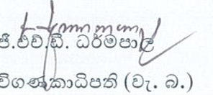

Action taken by the Management
Report of the Auditor General on the Financial Statements of Sri Lanka Anti-Doping Agency for the year ended on 31st December 2024, in terms of section 12 of the National Auditing Act No 19 of 2018.

- Factor -
Even if an employee is not recruited on an acting basis for an indefinite period to fill the position when a vacancy occurs under Section 2.2.2 of the Audit Report submitted by the Auditor General on 11th August 2025, Agency had made an acting appointment to the position of Director (Enforcement and Implementation) from 28.02.2023 without specifying a period. It is stated that Rs. 568,733.00 had been paid as working allowance by July 2025.
Management’s Comment

As per the recruitment process recommended by the Department of Management Services for the post of Director (Enforcement and Implementation) of the Agency, despite intensive efforts (including newspaper advertisements) to recruit a qualified applicant, an appointment for the position could not be made until 2023.

Therefore, the vacancy of that position created obstacles to carry out enforcement and implementation tasks as expected. To resolve this crisis, it was proposed at the first quarterly management meeting of year 2022 to recruit an Officer from the Sri Lanka Police who is not lower than the Staff Officer rank (especially with experience in the Narcotics Bureau).

Accordingly, pursuant to a request made by the Secretary of the Ministry of Sports and Youth Affairs to the Secretary of the Ministry of Public Security on 22.09.2022, Senior Superintendent of Police Mr.P.G. Darshana was appointed on an acting basis to fill the vacancy. Although this appointment is to be for a period of one year as per Section 9 of the Operations Manual for State Enterprises, the appointment letter states that it is on a temporary acting basis. Accordingly, it should be noted that this appointment is a temporary acting appointment and the Sri Lanka Anti-Doping Agency has the power to terminate the services of this officer at any time.

However, since this matter was continuously pointed out in Audit Committee meetings, this matter has been referred to the Board meeting of the Agency on 24.07.2025 through a Board paper. Accordingly, it was suggested that the institution still requires the services of this officer and that it should be obtained. Since no period has been specified in the appointment letter, can the services of this officer be further obtained at the discretion of the agency? Can the official term be extended? If not, it has been informed to inquire through the Secretary to the Ministry of Youth Affairs and Sports from the Secretary to the Ministry of Public Security, to appoint another suitable Senior Superintendent of Police. Accordingly, the Secretary to the Ministry of Youth Affairs and Sports has sent a letter of inquiry to the Secretary to the Ministry of Public Security regarding the period of the acting position of the Director (Enforcement and Implementation) on 31.07.2025, but no response has been received till date.

